GREATER CAMBRIDGE LOCAL PLAN PREFERRED OPTIONS
REG.18 CONSULTATION – NOVEMBER TO DECEMBER 2021
DENCORA DRAFT REPRESENTATIONS

INTRODUCTION
Consultation on Preferred Options for the Greater Cambridge Local Plan is taking place until 13th December 2021. This document sets out draft representations to the consultation. The final version of the representations will be uploaded to the Councils online consultation system in due course.

REPRESENTATIONS TO PREFERRED OPTIONS GCLP
On behalf of Dencora
Object:

Policy S/RRP: Policy areas in the rest of the rural area

We propose to provide a new policy framework or site allocation for future development at the Flint Cross site. The emerging local plan promotes a range of existing policy areas within the rest of the rural area outside of the rural southern cluster, which provide context for the development of specific locations responding to specific local circumstances.

A vision statement considers the provision of a Petrol Filling Station (PFS) and EV charging (Sui Generis), and motor side services including a drive through coffee shop (Use Class E) and small scale retail and employment development, together with associated vehicular access (including the provision of a new roundabout) and parking provision on land north of the A505 at Flint Cross. This will be promoted as part of the fourth coming Local Plan review.

The A505 has also been identified as being of importance when considering the Uttlesford Local Plan review with a report being prepared back in 2018 by the WYG (having been commissioned by Uttlesford District Council). This considered the A505 between its junction with the A10 at Royston in Hertfordshire and the A11 at Abington in Cambridgeshire and possible options to improve the safety of the link. This document clearly references Flint Cross as being a problem junction of significance.

The development site will therefore comprise: -

- The provision of a Petrol Filling Station (PFS) and associated retail facilities including Drive thru coffee shop.
- EV charging provision.
- Vehicular entry from an estate road connecting the A505 and the B1368 London Road with a new roundabout on the A505 and vehicular exit to the B1368 London Road to the north of the site.
- The stopping up of the existing highway to the west of the site and the provision of a roundabout to provide safe access into the site and help address an existing accident history associated with the A505 and B1368 and improve highway safety.
- Additional future employment land to help support the viability of the proposed development given the sizeable infrastructure costs
- Open space and landscaping and biodiversity enhancement

The site is located at the junction of the A505 and the B1368; and provides a unique opportunity to provide highway safety improvement, through significant works to the A505 and the provision of a new roundabout and associated infrastructure works at a cost of around £2,000,000. This is only deliverable through the provision of an employment led development. The A505 has a very poor accident history, which has resulted in a number of fatalities and series serious accidents over the years. This scheme will help facilitate the provision of a new roundabout and stopping up the existing B1368/A505 junction.

The existing A505 / B1368 London Road priority junction, which is currently substandard with highway safety issues, would be replaced by a roundabout which would result in reduced approach speeds; thereby improving highway safety records and reducing the risk of PIAs. Furthermore, the new highway layout arrangement includes improved road signage and street lighting to support the new layout and aid drivers, minimising the human factor element that contributes to most PIAs.

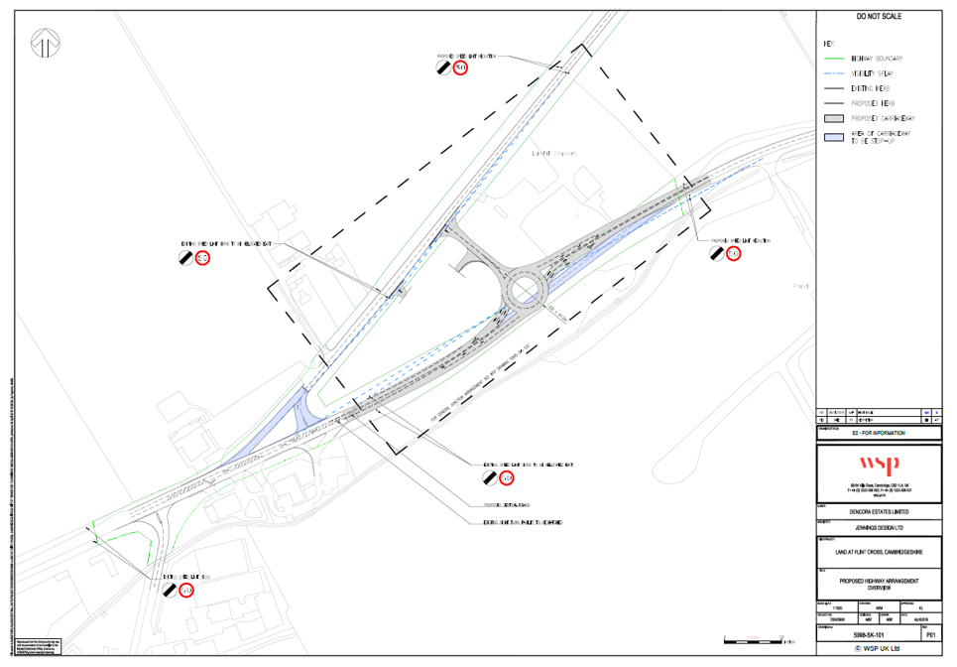

Proposed highway layout

Highway Safety improvements
- The A505 Corridor Improvement Feasibility Study: A10 to the A11 (Uttlesford District Council, 2018) highlights that along the entirety of the A505, recorded accidents (January 2013 to December 2017) are not distributed evenly but are concentrated in a relatively small number of locations, including through Flint Cross. Furthermore, accident data records for the highway network surrounding the proposed development site, obtained from Cambridgeshire County Council (CCC) for the five-year period covering January 2013 to April 2018, demonstrate the out of 20 Personal Injury Accidents (PIA) recorded, 18 (11 of slight severity, six serious in nature and one which was fatal) were recorded on the A505, indicating that highway safety is an area of potential concern.

- The A505 has a very poor accident history, which has resulted in a number of fatalities and series accidents over the years. This scheme will help facilitate the provision of a new roundabout and stopping up the existing B1368/A505 junction. There is a considerable infrastructure costs associated with such works, with WSP advising that such highway costs could be in the order of £2,000,000. This will need to comprise both a PFS and associated support facilities and some new employment development.

- WSP have modelled the roundabout junction based on PFS and Drive Through Coffee Shop. From the discussions that WSP have had with CCC providing a roundabout would be viewed very positively, as would closing the existing road B1368 London Road which is an access hot spot. A Stage 1 Safety Audit has been completed. It should be noted that CCC are not keen on traffic signals on their road network. This development must absorb the costs associated with the roundabout and the stopping up of the existing dangerous junction, together with more general development costs.

Roadside services, EV charging and PFS
- Roadside Services: the closest roadside services to Flint Cross are located on the A1 (Astwick – east), the M11 (Birchanger Green – south) and the A14 (Cambridge Services – north; and Newmarket – west). The Department for Transport’s (DfT) Circular 02/2013 indicates that the primary function of roadside facilities is to support the safety and welfare of the road user, and recommends that there should be no more than 28-miles or 30-minutes travelling time between such facilities. Whilst there is a PFS on the westbound carriageway on the A505, currently there are limited roadside facilities that support the welfare (toilets / refreshments) and safety (appropriate parking facilities to allow for drivers to rest) of road users along the A505 corridor, and there is no identified EV charging. As such, the nature of the proposed development will further support safety on the wider network whilst also providing welfare benefits to road users.

Employment Development
- The National Planning Policy Framework (NPPF) is an important material consideration. Paragraph 80 of the NPPF states that ‘planning policies and decisions should help create the conditions in which businesses can invest, expand and adapt. Significant weight should be placed on the need to support economic growth and productivity, considering both local business needs and wider opportunities for development. The approach taken should allow each area to build on its strengths, counter any weaknesses and address the challenges of the future. The existing Local Plan is also supportive of employment development. The scheme is designed to target specific businesses through business SIC codes, in this instance the R&D / science sector and manufacturing would be targeted first before targeting more traditional industrial occupiers as well as through our own internal database. There is a strong market need for this scale of development to continue to support employment growth within South Cambridge as without this more consented land occupiers will be forced to consider alternative out of the region.

Visual Impact
- Although the scheme is to be developed in detail, as referenced in the design report there is considerable potential to develop the site without adversely affecting the visual amenity of the Countryside regarding scale, character and appearance of new buildings and/or changes of use of land. The existing site is formed by mature landscaping and trees to the site perimeter. Substantial landscaping and bunding provides the site with a very good level of existing screening, which can be supplemented further. The submission is supported by a LVIA provided by LizLake to help assess the visual impact of the development. Overall, the Site and surrounding landscape has capacity to absorb a development of this nature and scale with only limited local effects on landscape character and visual amenity.

- The proposed development site is not located in an isolated location and is very well screened. Although further work is required, it is our view that there is the basis for significant and compelling material considerations as expressed above that outweigh the general presumption against development in the Countryside. There is good reason to support a site allocation of reference a potential opportunity area to help facilitate the highway safety improvements.

Carter Jonas – 8th December 2021

