Representations to Greater Cambridge Local Plan – First Proposals
On behalf of Cambridgeshire & Peterborough NHS Foundation Trust
Policy S/RRA/H/3 “Fulbourn and Ida Darwin Hospitals”
Savills (UK) Ltd are instructed by Cambridgeshire & Peterborough NHS Foundation Trust to make the necessary and relevant representations to the Greater Cambridge Local Plan – First Proposals Document which has been published for consultation.
We appreciate that the consultation documents reflect the fact that we remain at the early stage of plan preparation and that the document only sets out the broad policy direction of the new Joint Local Plan but nevertheless remains important for the Trust to engage in the plan making process.
In such a context, the Trust acknowledges the need for a Local Plan review having regard to the need for both local planning authorities to cater for significant growth that is anticipated to come forward and the consequent impact that such growth will have upon public services, including healthcare. The inter-dependency between the urban area of Cambridge and the rural hinterland encompassing some 100 villages on major new strategic development sites is very clear and justifies the need for a new Joint Local Plan to come forward.
The Trust is a landowner to the east of Cambridge and includes that area known as the Fulbourn Hospital site. The Trust formerly owned the Ida Darwin Hospital site further to the east but this was sold in late 2019 to Homes England. The site was sold to Homes England with the benefit of an outline planning permission for new residential development and was then sold on to a housebuilder.
It is the case that the Trust continues to provide a hugely important mental healthcare service on the Fulbourn Hospital site and more recently secured planning permission on 30 April 2021 for a new Resource Centre on the site (planning application reference 20/02887/FUL). The granting of this permission acknowledged that the site lies within the designated Green Belt and within the designated Conservation Area since this was the planning policy framework position at the time of the determination of the planning application.
In addition to the policy designation, it was the case that Policy H3 “Fulbourn & Ida Darwin Hospitals” was relevant given this policy formed part of the Development Plan. This policy is set out below
“Policy H/3: Fulbourn and Ida Darwin Hospitals
1. The redevelopment of the existing built footprint of the Ida Darwin Hospital into a different configuration, comprising residential redevelopment on the eastern part of the Ida Darwin site and the transfer of part of the building footprint to the Fulbourn Hospital site for new mental health facilities will be permitted.
2. Redevelopment will create a green wedge on the western part of the Ida Darwin site to provide a compensatory enhancement to the openness of the Green Belt in this location. This green wedge will also provide enhanced public access to the countryside.
3. Developers will be required to undertake ecological surveys and monitoring prior to the commencement of construction, and propose a Biodiversity Strategy for the protection and enhancement of biodiversity that establishes which areas will be protected and enhanced, and appropriate mitigation measures.
4. An investigation into land contamination will be required prior to the granting of any planning permission. Should this indicate that remediation should be undertaken, this must be done to a standard agreed with the Council and conditions will be imposed on any planning permission to ensure that development takes place in accordance with a programme which takes account of remediation work.
5. Appropriate investigation of noise and vibration in relation to the adjoining railway line will be required, and attenuation measures may be secured by condition as necessary.
6. Development Briefs for this sensitive location in the Green Belt between Cambridge and Fulbourn are required to be submitted to and approved by the Local Planning Authority prior to granting of planning permission.”
The Greater Cambridge Local Plan – First Proposals consultation document proposes that this policy be retained in a new Joint Local Plan (page 133 of the consultation document) The Trust cannot see a case why such a policy should be retained having regard to the following points:

- There is no link between the Ida Darwin Hospital site (which was sold to Homes England and subsequently sold to a residential developer) and the Fulbourn Hospital site. The “transfer of part of this building footprint to the Fulbourn Hospital site for new mental health facilities will be permitted” is wording that has no relevance to a new Local Plan given that the site has been sold off following the grant of planning permission and at the time of writing is the subject of a detailed planning application for some 203 dwellings and community provision (application reference 20/05199/REM).
- The broader issue of the importance of the Fulbourn Hospital site as a provider of critical healthcare services should not be constrained by unjustifiable planning policy restrictions which threaten the critical provision for important healthcare services. This is brought into even more acute awareness given the global pandemic and the importance of healthcare services in such a context.
- The wording of the policy which requires developers to undertake ecological surveys and monitoring, investigate land contamination and assess noise and vibration are all matters that are either out of date and therefore irrelevant or at least can be satisfactorily addressed through other policies in the plan.
In the circumstances where the former hospital buildings at Ida Darwin have now been demolished and planning permission granted (see above), there is no correlation between the floorspace on the Ida Darwin site and any new floorspace at Fulbourn Hospital.
- The final paragraph of Policy H/3 states that development briefs are required to be submitted and approved. It is the case that a development brief was prepared back in 2013 for the Ida Darwin hospital site but it is very clear that it is considerably out of date given that the document was prepared at a time when the Trust (as a landowner) had different aspirations for the Ida Darwin site. The brief was also prepared and supported a 2013 planning application for residential development on the Ida Darwin site which included a care home and which was ultimately refused at Committee. Thus, there is no case for a development brief needed for the Ida Darwin site and nor can we see a case for needing a new brief for the Fulbourn Hospital site although there may be the case for a masterplan to accompany any new application for development on the Fulbourn Hospital site.

Having regard to all the above points we cannot see any justification why Policy S/RRA/H/3 “Fulbourn and Ida Darwin Hospitals” would be carried forward into a new Local Plan.

Policy GP/GB “Protection and Enhancement of the Cambridge Green Belt”
One of the key policy directions within the new Joint Local Plan for Greater Cambridge is envisaged to be the retention of the Green Belt and the relevant policy justification that accompanies this designation. This follows on from references to Green Belt policy within National Planning Policy Guidance which sets out specific requirements for how planning proposals in these areas should be considered as well as providing the reasons why Green Belt designation applies to certain areas.
Paragraph 138 of the NPPF states:
“Green Belt serves five purposes:
a) to check the unrestricted sprawl of large built-up areas;
b) to prevent neighbouring towns merging into one another;
c) to assist in safeguarding the countryside from encroachment;
d) to preserve the setting and special character of historic towns;
and e) to assist in urban regeneration, by encouraging the recycling of derelict and other urban land”.
Paragraph 140 then states that Green Belt boundaries should only be altered where exceptional circumstances are fully evidenced and justified, through the preparation or of updating of plans. Consequently, the preparation of a new joint Local Plan provides the opportunity to review such boundaries and in such circumstances is entirely appropriate for the Trust to respectfully suggest the need to amend the Green Belt boundary at Fulbourn Hospital on the basis of the contribution (or not) it makes to Green Belt purposes.
The Trust is the landowner of land at Fulbourn Hospital. The site is bounded to the west by Yarrow Road, by Cambridge Road to the south and by Tescos and Fulbourn Old Drift to the north. The Green Belt designation covers the whole of the site despite a significant amount of built form located in the northern part of the site and planning permission having been granted on 30 April 2021 for a new Resource Centre. This latter development was granted through a demonstration of Very Special Circumstances having regard to the presence of the Green Belt designation and its inclusion as part of the Development Plan.
It is the view of the Trust that legitimate questions should be asked about the appropriateness of including the Fulbourn Hospital site within the Green Belt given the significant amount of built form in the northern part of the site and the consequent character of the site in question. It is also relevant to refer to the commentary contained within the evidence base prepared in support of the initial work on the Local Plan. Topic Paper 5 is the Greater Cambridge Green Belt Assessment report and Appendix B to that document specifically relates to Site CH15 which is the land parcel including Tescos, Fulbourn Hospital and Capital Park immediately east of the hospital site. It is the view of the Trust that the largely built up nature of certainly the northern part of CH15 is such that it merits removal from the Green Belt.
Site CH15 is shown below as an extract from Appendix B to the Green Belt Assessment (Appendix B – Cambridge – Arbury to Cambridge North”)
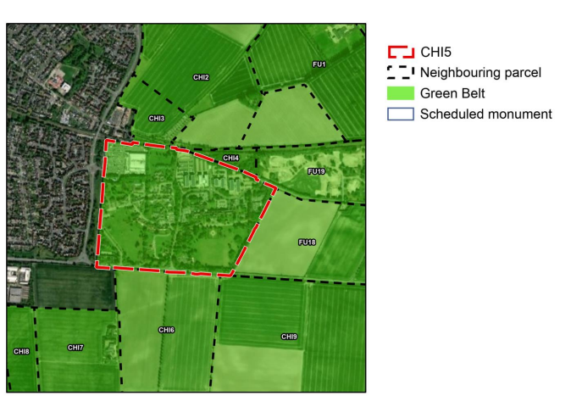

Indeed the Green Belt assessment for Site CH15 above states:

“While the southern area of the parcel is more open, the parcel contains more significant urbanising elements including Fulbourn Hospital, Capital Park and a Tescos superstore”. The whole of land parcels CH15 lies adjacent to the existing built up area and it is acknowledged that the presence of a tree line and the edge of the built up area along Yarrow Road means that the views are dominated by urban development which is certainly not a characteristic in our view having regard to Green Belt designation.
Having regard to the three purposes of including land within the Green Belt, we make comment on each of these three purposes in italics below:
Cambridge Purpose 1 - To preserve the unique character of Cambridge as a compact, dynamic city with a thriving historic centre
The Green Belt assessment acknowledges that the contribution is limited. It states that the parcel has some relationship with the urban area and we would certainly confirm that is the case since it lies adjacent to the built up area. The assessment concludes that the parcel makes a “relatively limited contribution to Cambridge Purpose1”
Cambridge Purpose 2– to maintain and enhance the quality of Cambridge’s setting.
It is certainly the case that Fulbourn Hospital, Tescos and Capital Park weaken the rural character of this edge of the City and whilst it is acknowledged that the land falls within Fulbourn Conservation Area this do not relate to land being included within the Green Belt nor the justification for it. Whilst it is the case that the southern parts of the land parcel have more open elements, it is the built up areas to the north and that character which dilutes the importance of including the land within the Green Belt. It cannot be the case that the built up area contributes positively to the character and the landscape and setting and thus there is no case for built up areas such as those being included within Green Belt designation.
Cambridge Purpose 3– to prevent communities in the environs of Cambridge from merging into one another and with the City.
It is the case that the Green Belt assessment confirms that the contribution in this context is “relatively limited” because the land forms an area between Cherry Hinton and the village of Fulbourn where an urbanising development reduces any perceived separation.
It is clear that the Council’s technical assessment work which has looked at the contribution that Parcel CH15 makes to the Green Belt has led to a conclusion which places the land parcel CH15 in the “Moderate High” harm rating as shown in Figure 4.4 below. It is our view that that the character of the land parcel is such that it cannot be classed as a single site since there are clear differences between the more open southern areas at Cambridge Road and the far more built up areas to the north. It is considered that the built up areas to the north of the land parcel including the footprint of the buildings at Fulbourn Hospital should be removed from the Green Belt

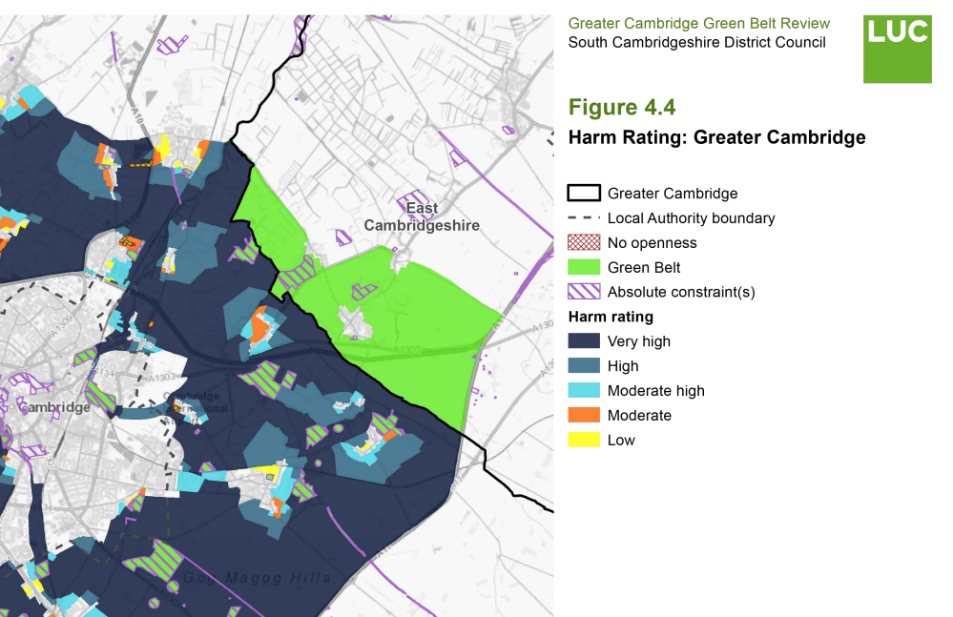

The enclosed plan (taken from the Adopted Local Plan 2018) shows the suggested revision to the Green Belt boundary at it affects the Fulbourn Hospital site.

