**Thriplow and Heathfield Neighbourhood Plan Consultation 30 September 2024**

**Comments on behalf of the British Horse Society**

The BHS fully supports this proposal. Any new ROW created should be bridleways or byways. Local equestrians would like to see more of the ROW access available to them. Public money should be spent inclusively and include all non-motorised users. This includes money from Developers for new ROW.

Whilst we support maintenance of PROW’s, the work ‘improvement’ can become synonymous with changing a rural right of way to a tarmac path for cyclists. We would strongly oppose such changes. Any change of surface to the PROW now has to be applied for with the opportunity for the Cambridgeshire Local Access Forum to object.

There is a paucity of rights of way in Thriplow:

The Cambs ROWIP acknowledges that the bridleway network is disjointed, inadequate and in need of improvement. There is an opportunity to improve the bridleway network and thereby access for equestrians (it is acknowledged that there is a large number of equestrians in the parish) by upgrading footpaths to bridleways. We would ask that this is included on the wish list within the Plan.

Improvement to the network can act as a catalyst to further improve the network for all users when opportunities become available.

Another route to improve the PROW is by the inclusion of lost highways – historic public routes which have never been extinguished but are not currently on the Definitive Map. The BHS is aware of three such routes in Thriplow marked bright blue on the attached map:

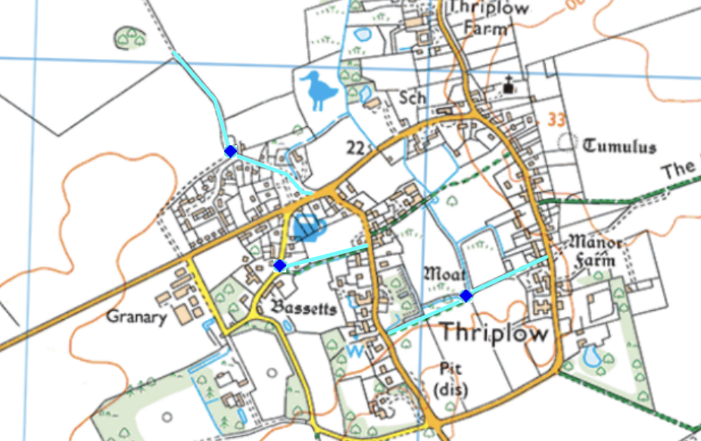

All need further investigation and if the evidence is found, DMMO applications need to be submitted. Currently, the BHS does not have the capacity to undertake these applications, but we would like them recorded on the NP as potential public rights of way of at least bridleway status. These routes should be investigated if they are threatened by any form of development.

Newton is equally bereft of bridleways:

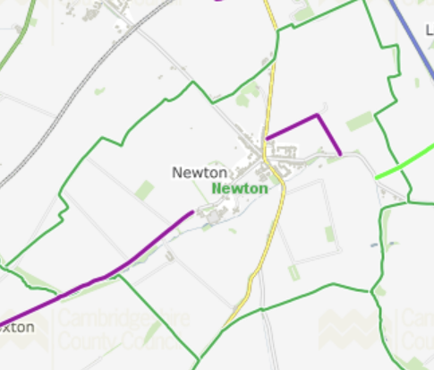

However, again we are aware of routes which may be lost highways:

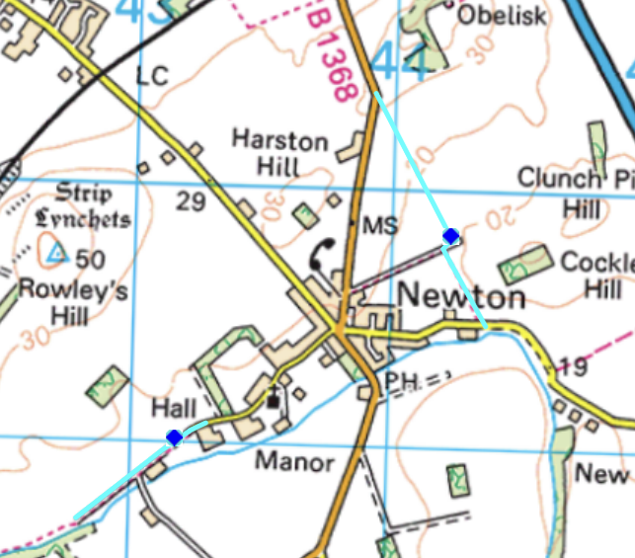

When considering any changes to road layouts, consideration should also be given to equestrians. In the Highway Code Hierarchy of road users – pedestrians are listed as the most vulnerable road user, followed by horses and cyclists. This new rule highlights that, irrespective of method of transport, those who can do the greatest harm have the greatest responsibility to reduce the danger or threat they may pose to others.

Public money should be spent inclusively to include all Non Motorised Users (NMUs), which includes equestrians and disabled mobility scooters. The majority of equestrians are female, compared to the majority of cyclists being male. There should not be an inequality in how these road users are treated when it comes to road safety.

Any changes/‘improvements’ to road layouts for the benefit of cyclists must not put equestrians at greater risk. If there is an accident, as a result of a change to the road layout which disadvantaged equestrians, in which an equestrian was injured then the Council could be considered to be liable.

**Additional Comments and information from the British Horse Society**

I welcome the opportunity to comment on the local Neighbourhood Plan, and to be able to put forward an equestrian point of view which can often be overlooked by Councils when considering Active Travel proposals.

Safe routes for equestrians are desperately needed because the accident statistics in respect of horses on the roads are horrific. There have been 5,784 incidents reported to the British Horse Society since 2010, 44 people have lost their lives, 1350 have been injured, 441 horses have been killed, 1,198 horses injured, and 75% of these incidents involved vehicles passing too close to the horse and/or too fast.

The British Horse Society is the UK’s largest equestrian Charity, with over 119,000 members representing the UK’s 3 million equestrians. Nationally horse riders have access to just 22% of the rights of way network and carriage drivers to just 5%. This network has become increasingly fragmented by roads, which were once safe rural routes, but have now often become busy thoroughfares.

Whilst the Society supports the national initiative to encourage more cycling and walking as part of Active Travel Plans, it is imperative that the Council recognises that Active Travel also includes equestrians.

**Central government support for including horses:**

The government's Cycling and Walking Investment Strategy Safety Review says: "1.2 But safety has particular importance for vulnerable road users, such as walkers, cyclists and horse riders. All road users have an equal right to use the road, and safety and the perception of safety are key factors in determining how far people use these modes of transport. The safer they feel, the more they will use these active modes of travel. The more people who use Active Travel, the fitter and healthier they will be, and the more their communities will benefit from lower congestion and better air quality, among a host of other benefits"(Jesse Norman, Minister for Transport.

**Jesse Norman in House of Commons debate on Road Safety, 5 November 2018:**

“We should be clear that the cycling and walking strategy may have that name but is absolutely targeted at vulnerable road users, including horse-riders”

And final point by Jesse Norman in debate: “Horse riders are vulnerable road users—there is no doubt about that, and there never has been—and they have been included in the work we are doing.”

**Newly Constructed Paths**

Any physical creation of new paths to achieve Active Travel objectives within the county is to be welcomed (provided that equestrians are included, as a minimum, on those outside of large town centres), as this will enhance the ability of the public to increase its access to safe off road routes for leisure and commuting. District Authorities should take a strategic approach to Active Travel proposals within their administrative boundary - giving consideration to potential links outside their boundaries that could contribute to a more integrated network and achieve maximum benefit for all users.

**Use of Existing Public Rights of Way**

I recognise that some of the routes within this consultation could be in urban areas. However, many horses are kept on the urban fringe, so it is important that equestrians are not excluded from routes that exit the urban areas into the surrounding environs.

Active Travel routes should not, in any way, compromise the use of the public rights of way by making them less amenable to existing lawful users of the right of way. In particular:

• Where existing routes are considered as part of the plan, it is important that all user groups are consulted so that the impact on other lawful users can be assessed and, if necessary, alternative measures discussed.

• For each specific proposal which uses a public right of way or minor road, the width, the proposed surface and the impact of increased estimated numbers of cyclists must be considered in order to design a route suitable for all legal users in each specific location.

• Any newly constructed paths should be integrated/physically linked with the existing public rights of way network where possible and needed, clearly waymarked and recorded on either the definitive map or another publicly accessible map as appropriate.

• Where proposed new, or improved routes have crossing points or junctions with the main highway network, appropriate signal-controlled (or even grade-separated) crossings should be provided suitable for all user groups.

• Consideration should be given to the use of ‘Quiet Lanes’1 where the speed of traffic is reduced.

• Where motorised traffic is to be prohibited on either a right of way or minor road to facilitate cycling and walking, it must be remembered that this is likely to also benefit equestrians. Signage and structures must not impede equestrians

**Other Considerations to Note**

Commuting cycling is likely to take place at times other than when recreational use takes place. Thus, a path used for commuting may well be used for recreational travel especially if it provides a circular route by connecting to other paths.

Several categories of public rights of way (bridleways, restricted byways and byways) and minor public roads are already shared by cyclists and other user groups. Thus, as a general principle, we believe that, for maximum public benefit and fairness, the reciprocal approach should be implemented, i.e. that new cycle paths should be shared with other user groups unless there is a specific, unresolvable reason not to do so.

Use of Traffic Regulation Orders to prohibit use of a public right of way by a specific user group for the benefit of cycling needs to be fully justified and take into account the rights of other lawful users. It should be noted that the Defra Statutory Guidance to local authorities on Rights of Way Improvement Plans, 2002, states in para. 2.2.21:

*‘There is potential for conflict on ways carrying higher rights between different classes and types of users. Wherever possible proposals for improving rights of way should not unduly benefit one class of user at the expense of another. Improvements that are intended to benefit cyclists, harness-horse drivers, horse riders or walkers should not unduly restrict lawful MPV use of public vehicular rights of way’*.

Equestrian use must be considered when Active Travel routes are proposed in new developments, so that new links can be created to the countryside beyond. Where new bridges/underpasses are proposed these should be suitable for equestrian use.

**Effect of excluding Equestrians from Active Travel Routes**

If equestrians are not an included user on active travel routes, the consequence is that equestrians are left on the carriageway with lorries and cars passing them on the outside and cyclists passing them on the inside, which is another accident waiting to happen. It is therefore important that this aspect is considered in the risk assessment for such routes.

**The Health Benefits of Horse Riding in the UK.**

(Data comes from research undertaken by the University of Brighton and Plumpton College on behalf of The British Horse Society)

• 68% of questionnaire respondents participated in horse riding and associated activities for 30 minutes or more at least three times a week. Sport England estimate that such a level of sporting activity will help an individual achieve or exceed the government’s recommended minimum level of physical activity.

• Women have been identified in government studies as a social group with relatively low levels of participation in physical activity. Some 93% of questionnaire respondents were women and 49% percent of female respondents were aged 45 or above. These are comparable figures to a major Sport England survey which found that 90 percent of those participating in equestrianism are women and 37 percent of the female participants in equestrianism are aged 45 or above. The gender and age profile of equestrianism is not matched by any other sport in the UK2 .

• Amongst the horse riders who took part in the survey, 39% had taken no other form of physical activity in the last four weeks. This highlights the importance of riding to these people, who might otherwise be sedentary.

• Horse riders with a long-standing illness or disability who took part in the survey are able to undertake horse riding and associated activities at the same self-reported level of frequency and physical intensity as those without such an illness or disability.

For further information, please see: <https://www.bhs.org.uk/~/media/documents/marketing/health-benefits-of-riding-in-the-uk-full-report.ashx?la=en>

**Benefits of catering for horses**

The British Equestrian Trade Association National Equestrian Survey (2019)3 indicated:

• £4,174 is spent per horse which represents a significant contribution to the economy

• The value of the equestrian sector is £4.7 billion per annum

General Statistics

• 847,000 horses in Britain

• 1.8 million regular riders of 3 million total

• Lack of access to horses and riding facilities is a barrier for 22% of lapsed riders returning

REASONS TO INCLUDE EQUESTRIANS in the Neighbourhood Plan

* In 2017 the equestrian industry excluding the racing industry, contributed £4.3bn to the economy and is the second largest rural employer.
* The equestrian industry relies on a network of safe, off road access to the countryside.
* It was established at a Cambridgeshire County Council Planning meeting that, with good design, it costs no more to provide access for equestrians.
* Horses safely and happily share paths less than 3m wide all over the country.
* No report ever of any injury to a third party on any RoW by a horse.
* The Cambs RoWIP (Rights of Way Improvement Plan) states that the bridleway network is inadequate, fragmented and in need of improvement. Every shared pedestrian / cycle path further fragments that network.
* The majority of cyclists are male (78% : Sustrans) whereas the majority of horse riders are female (BHS).
* Horse riding has mental and physical health benefits. Older women particularly participate in this activity, where they may not otherwise exercise.
* Horse riders are a vulnerable road user, in the same way as walkers and cyclists.
* Equestrian accident statistics
* In the UK the period November 2010 to March 2019 road incidents involving horses :
* 43 humans died
* 315 horses died
* 3757 incidents were reported to the British Horse Society (BHS) although it is believed that this represents only 10% of the actual incidents.
* The East of England is one of the regions with the highest accident rate

Cambridgeshire County Council has a Local Transport Policy (LTP), which sets out their transport objectives, policies and strategy for the county. A sister document of the LTP is the Rights of Way Improvement Plan (ROWIP). The County Council updated its ROWIP in 2016 in line with the Countryside and Rights of Way Act 2000. You may wish to consult this document when drafting policies dealing with Non-Motorised Users (NMU) and the Public Rights of Way network. <https://cambridgeshire.gv.uk/residents/travel-road-and-parking/transport-plans-and-policies/local-transport-plan>

Particular interest should be given to Policies S0A1 ‘Making the Countryside More Accessible’, S0A2 ‘A Safer Activity’, S0A3 ’57,000 New homes’, S0A4 ‘Knowing what’s out there’, S0A5 ‘Filling in the Gaps’, and S0A8 ‘A Better Countryside Environment’– all of which include the need for access for equestrians.

Lynda Warth

County access & Bridleways Officer – Cambridgeshire

British Horse Society