CamToo: a strategic opportunity to address rowing capacity constraints with wider infrastructure benefits

Executive summary
Rowing on the River Cam is one of Cambridge’s most intensively used sporting activities. Around 1,500 college rowers and more than 1,000 town rowers use the river regularly, many several times a week. Despite strong and sustained demand, especially in town rowing, the physical capacity of the river has remained unchanged for decades, and participation growth has lagged significantly behind the city’s population growth (approximately 15% growth compared with around 30% population growth over the last 20 years).
This note revisits the CamToo concept as a means of addressing this long-standing constraint through the provision of additional safe training water. It also highlights how doing so could create opportunities to deliver wider strategic benefits related to transport connectivity, water infrastructure, flood resilience, climate adaptation and wellbeing.
The original CamToo vision, developed in the mid-2000s, combined a new river channel suitable for rowing with flood relief and a potential public transport crossing of the River Cam. Since then, major elements of the wider transport vision — notably Cambridge North station and associated active travel links — have been delivered. What remains are a set of interlinked civil engineering opportunities which, if considered together, could address several strategic challenges more effectively than if pursued in isolation.
At the heart of the proposal is the construction of one or more new river channels connected to the existing River Cam. These channels would provide dedicated rowing water while also offering flood conveyance and storage. Excavated material could be reused on site to form raised platforms within the floodplain, enabling other infrastructure uses.
Considered individually, none of these challenges is straightforward. Considered together, they present an opportunity for an integrated solution in which sporting provision, water management, transport resilience and landscape enhancement reinforce rather than compete with one another.

Background and strategic context
Since the original CamToo proposals were developed in 2006, Greater Cambridge has experienced significant population growth, increased pressure on infrastructure, and a growing need for climate adaptation.
Rowing remains a major city-wide activity with a distinctive collegiate and community character. However, growth in participation has been constrained by limited river space, safety considerations and conflicts between different river users. At the same time, questions around the long-term resilience of water treatment infrastructure and flood management have become more prominent.

CamToo1: Stourbridge Common and Ditton Meadows
CamToo1 corresponds to the original core site across Stourbridge Common and Ditton Meadows, where a new river channel would run broadly parallel to the existing River Cam.
The channel would provide additional dedicated rowing water suitable for daily training, significantly increasing effective river capacity. It would also deliver additional flood conveyance and storage and create a linear landscape feature integrated with the commons and existing public access.
Indicative assumptions for CamToo1 are:
- approximately 1,600 metres in length.
- approximately 30 metres in width, reflecting the landscape constraints of the commons.
- approximately 2.5 metres in depth.
- Stourbridge Common and Ditton Meadows approximately 0.5 metres above river level.
On this basis, CamToo1 could generate in the order of 240,000 cubic metres of excavated material. In the original concept, this material was envisaged for reuse in associated infrastructure works, including embankments linked to a potential public transport crossing of the River Cam — the long-identified missing link between Cambridge North / the Science Park and East Cambridge (Barnwell and Newmarket Road).
The scheme assumes that the new channel would run broadly in parallel with part of the existing river, enabling operational changes that improve training efficiency and reduce conflicts along the most intensively used stretch.

CamToo2: Northern river channel and Water Treatment Infrastructure opportunity
CamToo2 applies similar principles further north on land bounded by the A14 to the south, the Cambridge–Ely railway line to the west, and the River Cam to the east.
The entrance to the new river would be at the southern end of the site, approximately halfway between the A14 and Baitsbite Lock. The northern end would be where the existing river runs close to the railway near a WWII pillbox (OS Grid Reference TL 50300 64800).
For indicative planning purposes, CamToo2 assumes:
- a channel approximately 1,800 metres long.
- approximately 40 metres wide (enabling safe overtaking in both directions).
- approximately 2.5 metres deep.
- existing fields 0.5 metres below upper river level.
The wider channel provides increased operational flexibility and additional water capacity. Excavation is expected to generate approximately 200,000 cubic metres of material.
The site area is approximately 25 hectares, of which around 10 hectares could be raised by approximately 2 metres to accommodate operational plant, buildings and access associated with a relocated Cambridge Water Treatment Plant. Further material could arise from excavation of settlement tanks and lagoons.
Isolating gates at the entrance and a weir at the northern end would control flows. Milton Fen Road would be diverted around the new channel to provide access to the Lock Keepers cottage, with principal construction access assumed to be from Waterbeach. This would also allow access to the railway line, (Network Rail have confirmed they do not have any wayleave alongside the line).
We have created an indicative sketch of CamToo2 at the end of the document. It is not to scale.

Rowing capacity and wider benefits
Each scheme would increase by approximately 50% the length of prime training water accessible downstream from the city boathouses. Together, they would significantly relieve pressure on one of the most intensively used sporting assets in Cambridge.
Beyond rowing, the schemes offer opportunities to:
- support the long-term relocation and modernisation of water treatment infrastructure
- preserve and potentially enable strategic transport connectivity
- enhance landscape quality and public access
- deliver measurable wellbeing benefits
- improve flood resilience and water management
Neither CamToo1 nor CamToo2 conflicts with independent proposals for a standalone international-standard rowing lake at Milton Country Park. The CamToo channels are conceived as multi-use river infrastructure focused on training and everyday use, complementary to any future competition facility.

Indicative cost and land
Very high-level benchmarks suggest capital costs could plausibly range from several tens of millions of pounds up to around £80 million per scheme, depending on scope, phasing and the extent of associated infrastructure delivered. These figures are based on high-level AI-derived benchmarks for comparable civil engineering projects and are intended to provide order of magnitude rather than a detailed estimate.
Excavation of the new channels is estimated to account for roughly a quarter of total costs, at around £20 million, with the balance reflecting structures, water control, access, environmental mitigation and associated infrastructure..
Land costs are not included. Stourbridge Common is public land; Ditton Meadows is owned by Caius College (CamToo1). The ownership of land associated with CamToo2 has not been established.

An integrated opportunity
CamToo1 and CamToo2 should be seen as components of a broader, integrated response to Greater Cambridge’s long-term challenges. By addressing rowing capacity first, while enabling solutions to wider infrastructure needs, the proposals invite consideration of whether problems that are difficult to solve individually might be more tractable when approached together.
CamToo2, by potentially enabling relocation of the Water Treatment Plant, could unlock the existing site for development, increasing demand for transport connectivity and reinforcing the case for CamToo1.
The question posed is not whether these schemes should proceed as described, but whether the underlying opportunity merits renewed strategic exploration.

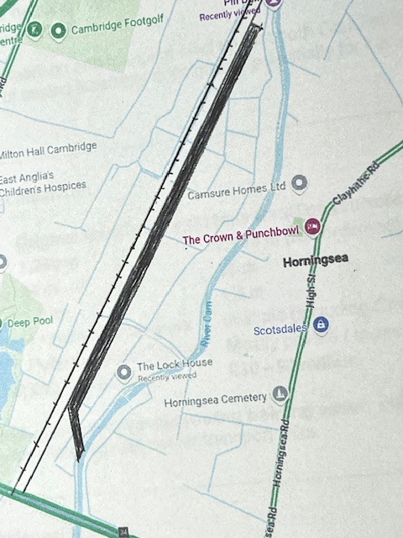
Sketch of CamToo2

The A14 lies at the lower (southern) end of the sketch. The northern end shows the river–railway pinch point referred to in the text; the WWII pillbox is located just beyond the extent shown. Milton Fen Road is indicated by the two ditches between the railway line and the Cam to the north of the Lock House.
We envisage that the towpath would continue between the railway line and the new river unless there was finance available for a bridge over the entrance to the new river.
The sketch indicates that there appears to be sufficient land between the proposed new channel and the existing River Cam to accommodate a relocated Water Treatment Plant (approximately 25 hectares), subject to detailed technical and environmental assessment.
This sketch is intended to illustrate feasibility and spatial relationships only. We are also exploring whether members of the rowing community with relevant skills could assist by producing indicative digital plans of both CamToo1 and CamToo2, should this be helpful for further discussion.

