Coldhams Lane junction was formerly a safe pedestrian route.

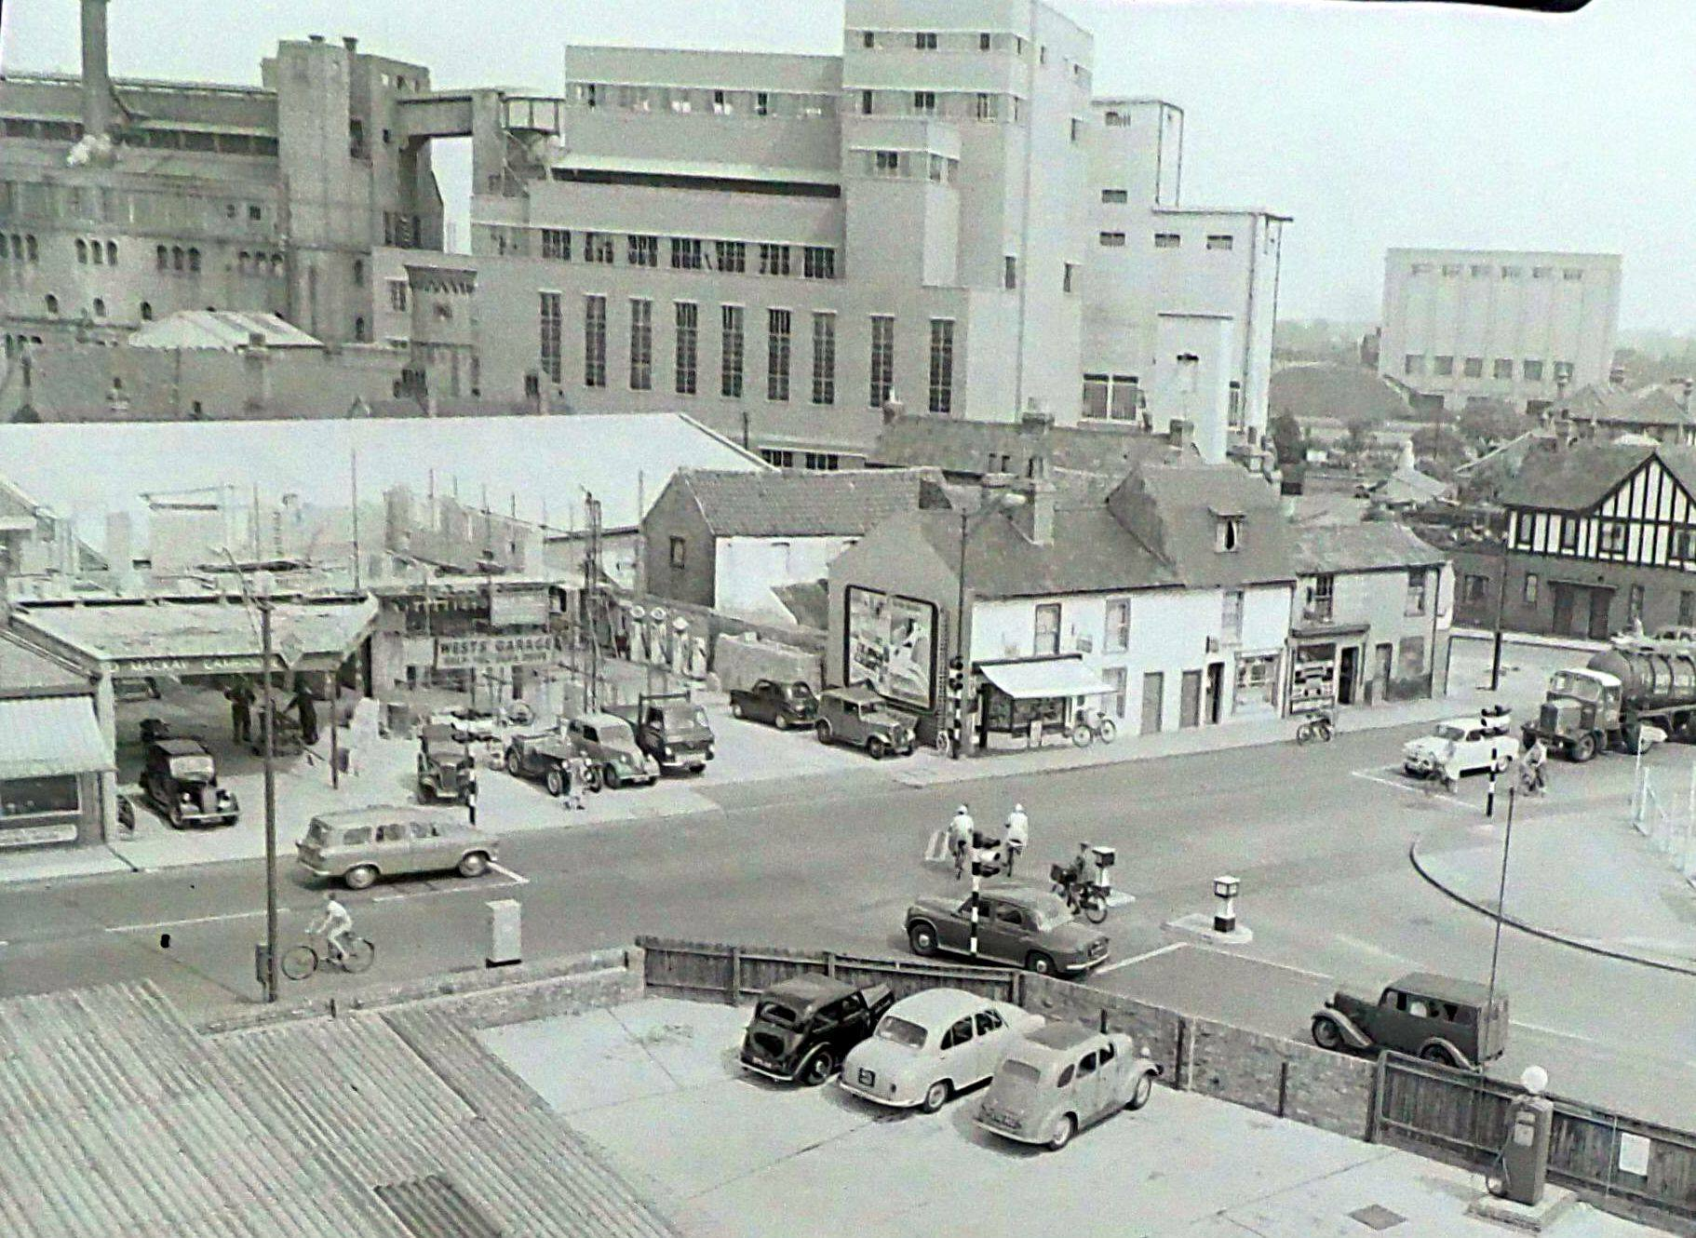
Cambridge Gas Works 1959 (Cambridge News reference no 228.95)
Taken from Cambridgeshire & Huntingdonshire History Facebook page (https://www.facebook.com/groups/1026849820769556/posts/1102301723224365/) ref: Mike Petty, Cambridge GAS Chronicle Developments in the supply of Gas in Cambridge 1888 to 1990 https://archive.org/details/CambridgeGASChronicle

