GREATER CAMBRIDGE LOCAL PLAN (GCLP) – FIRST PROPOSALS
REGULATION 18: PREFERRED OPTIONS
REPRESENTATIONS: KB TEBBIT LTD – LAND OFF CHAPEL ROAD, GREAT EVERSDEN (SITE REF: 40212)

INTRODUCTION
- We act for KB Tebbit Ltd in respect of Land off Chapel Road, Great Eversden (Site Ref: 40212). The boundaries of the site are shown on the image below which offers the opportunity for a sympathetic development which relates well to the existing settlement form.

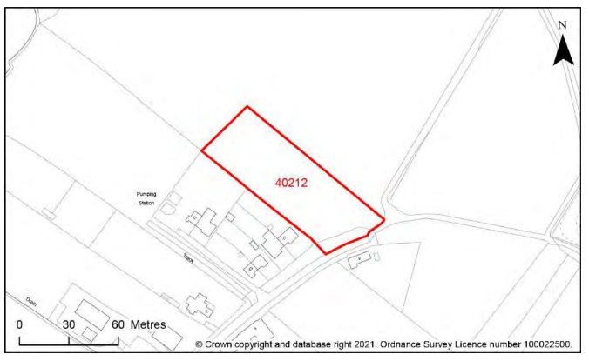

- On behalf of our client, we make the following comments on the Regulation 18 Preferred Options Consultation.

S/RRA: ALLOCATIONS IN THE REST OF THE RURAL AREA
- Land off Chapel Road, Great Eversden (HELAA Site Ref: 40212) as shown edged red on the plan below offers the potential for a sympathetic development which will fit well with the existing form of the settlement.

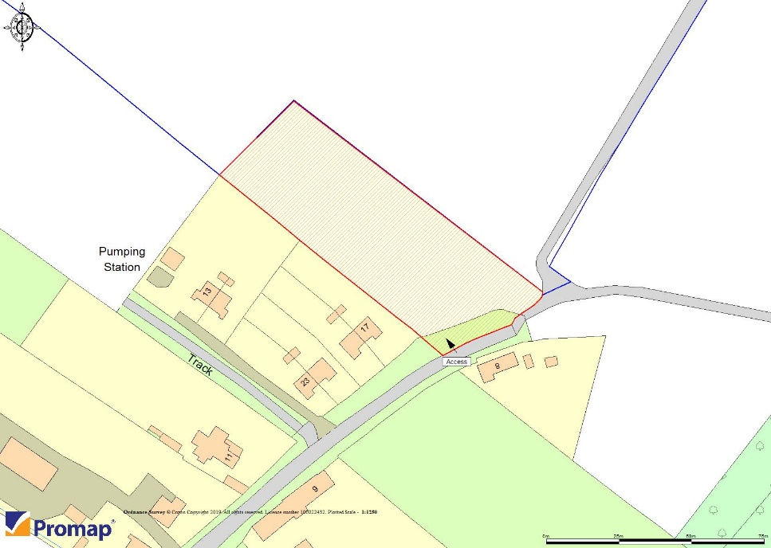

- Small allocations in Infill Villages that are well related to the existing form of the settlement will help to deliver a broader range of housing stock including affordable housing.

- We have analysed the local authorities HELAA review which appraises the development potential of the site. The HELAA review provides an accurate assessment of the site and we highlight that the site scores well with no constraints to development identified (please see the summary below).

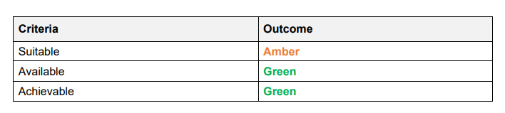
- For the reasons highlighted in this representation we encourage the Local Planning Authority to amend the Development Strategy in the GCLP by including more allocations in rural settlements. Chapel Road, Great Eversden (HELAA Site Ref: 40212) scores well in the HELAA review and should be identified as a residential allocation.

